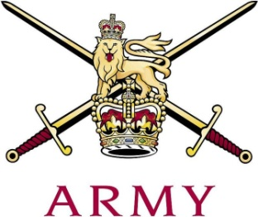
ARMY CRESTA

The Novice Cup 2020
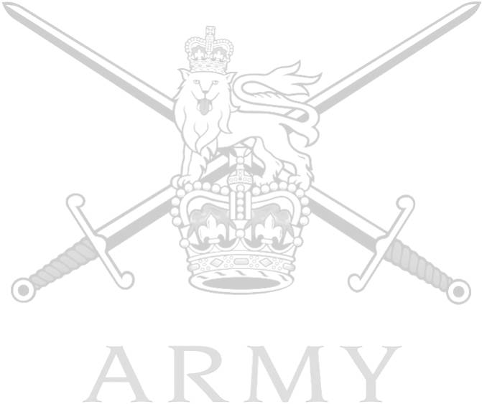

Ser | Name | Regiment | 1st | 2nd | Grand Total
1 | Tpr C Burnett | Blues and Royals | 46.78 | 47.27 | 94.05
2 | Tpr TR Wraight | Life Guards | 48.12 | 48.13 | 96.25
3 | 2 Lt S Kaye | Life Guards | 49.20 | 48.55 | 97.75
4 | 2 Lt T Muir | Life Guards | 49.64 | 50.70 | 100.34
5 | Lt BH Vickers | Army Air Corps | 50.02 | 52.37 | 102.39
6 | Capt CJ Hartland | Army Air Corps | 51.64 | 51.98 | 103.62
7 | Tpr C Jacques-Smith | Royal Lancers | 52.54 | 53.84 | 106.38
8 | Tpr B Marks | Kings Royal Hussars | 57.66 | 57.01 | 114.67
9 | Tpr B Thompson | Royal Lancers | 61.65 | 62.50 | 124.15
10 | Tpr MG Keith | Scots Dragoon Guards | 66.83 | 59.14 | 125.97
11 | Capt SS Brown | Scots Dragoon Guards | 62.01 | 65.48 | 127.49
12 | Lt F Howes | Intelligence Corps | 64.81 | 67.96 | 132.77
 | 2 Lt RKM Lewis | 3 SCOTS | 54.08 | Fall (S)
 | 2 Lt ERM Smith | 3 SCOTS | 56.14 | Fall (S)
 | Capt JII Ramsey | 3 SCOTS | 57.07 | Fall (S)
 | Lt H Fair | Kings Royal Hussars | Fall (S)
 | Lt A Nichol | Kings Royal Hussars | Fall (S)
 | Tpr B Matanle | Kings Royal Hussars | Fall (S)

