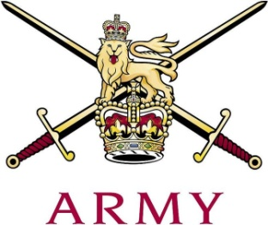
ARMY CRESTA

The 17th/21st Lancer Cup
Inter-Regimental Junction Championships 2020

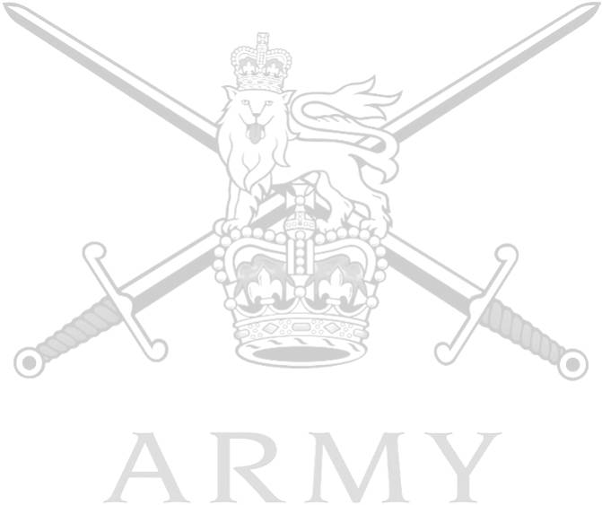
Ser | Name | Regiment | 1st | 2nd | Total
1 | Maj JB Barnes | Blues and Royals 1 | 44.35 | 44.35 | 181.38
 | LCpl W Fairbairn | Blues and Royals 1 | 46.34 | 46.34
2 | LCoH R Tonkin | Blues and Royals 2 | 46.26 | 46.26 | 186.57
 | Tpr C Burnett | Blues and Royals 2 | 46.78 | 47.27
3 | Maj PJR Chishick | Life Guards 1 | 45.61 | 45.61 | 187.47
 | Tpr TR Wraight | Life Guards 1 | 48.12 | 48.13
4 | Capt T Wythe | Royal Lancers 1 | 43.96 | 43.96 | 190.37
 | Tpr AR Price | Royal Lancers 1 | 49.62 | 52.83
5 | 2 Lt S Kaye | Life Guards 2 | 49.20 | 48.55 | 198.09
 | 2 Lt T Muir | Life Guards 2 | 49.64 | 50.70
6 | Capt CJ Hartland | Army Air Corps 1 | 51.64 | 51.98 | 206.01
 | Lt BH Vickers | Army Air Corps 1 | 50.02 | 52.37
7 | Lt F Howes | Intelligence Corps 1 | 64.81 | 67.96 | 245.79
 | Cpl I Leigh | Intelligence Corps 1 | 55.27 | 57.75
8 | Capt SS Brown | Scots Dragoon Guards 1 | 62.01 | 65.48 | 253.46
 | Tpr MG Keith | Scots Dragoon Guards 1 | 66.83 | 59.14

